**EXP 2 :-** LED CHASER

**CIRCUIT DIAGRAM**

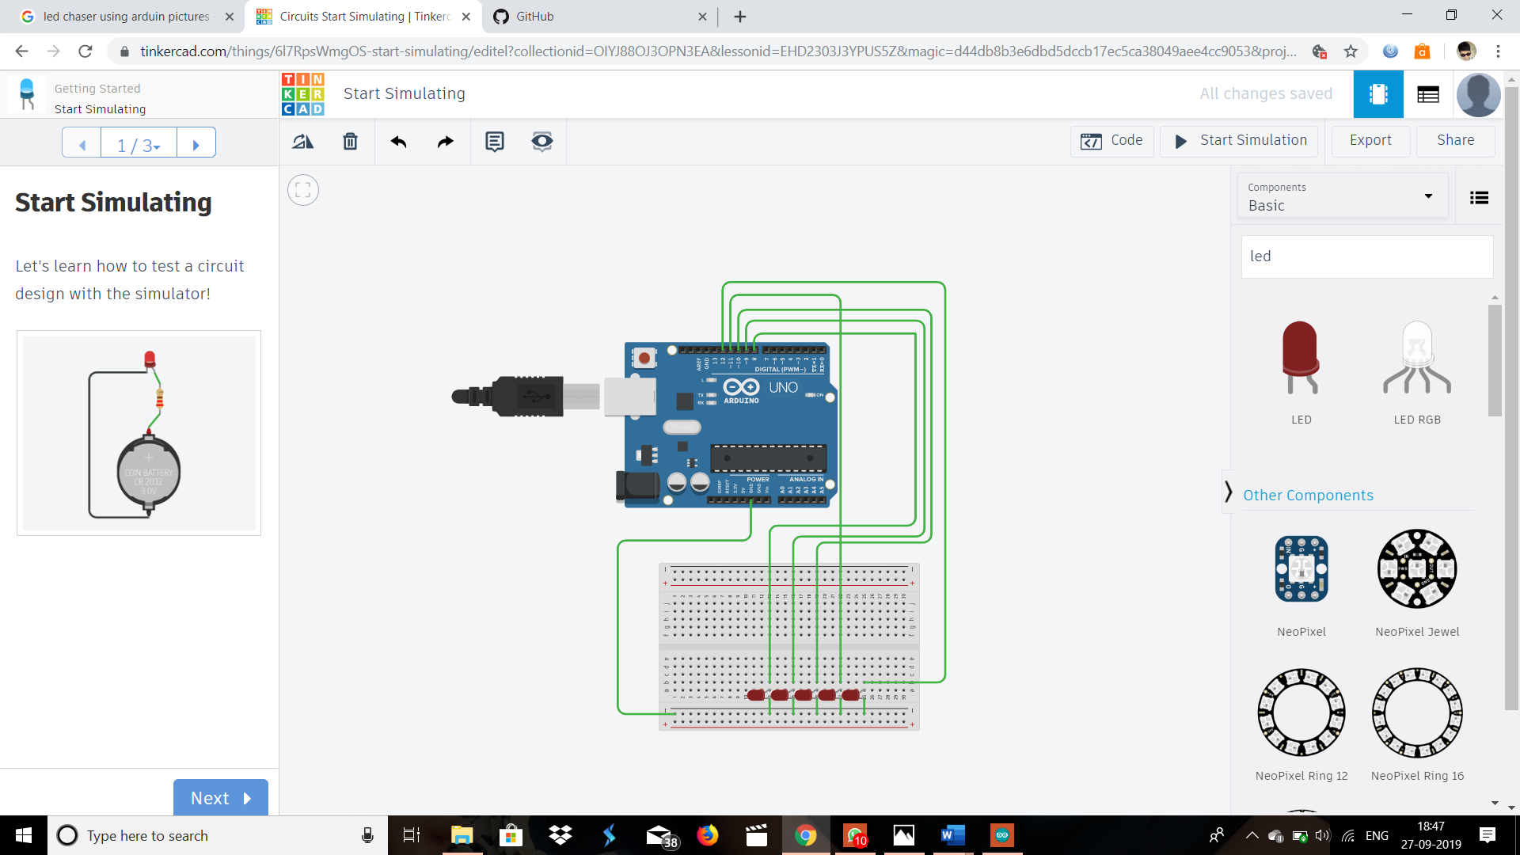

**APPARATUS REQUIRED :-**

1. LED
2. Breadboard
3. Arduino UNO
4. Connecting wires

**THEORY:-**

STEPS

1. Take 5 LEDs of different colors.

2. Connect the cathode end of all LEDs to the GND pin of Arduino.

3. Now connect the anode end of the led to the pin 8, 9, 10, 11,12 of the Arduino.

4.Do connections same as circuit diagram.

5.Write a code and upload it on Arduino

To upload code into arduino, need to attach arduino with pc using USB cable which is come with arduino board.

CODE:-

void setup(){

for(int i=8;i<=12;i++)

pinMode(i,OUTPUT);

}

void loop(){

digitalWrite(12,HIGH);

delay(10);

digitalWrite(12,LOW);

delay(10);

digitalWrite(11,HIGH);

delay(100);

digitalWrite(11,LOW);

delay(100);

digitalWrite(10,HIGH);

delay(1000);

digitalWrite(10,LOW);

delay(1000);

digitalWrite(9,HIGH);

delay(1000);

digitalWrite(9,LOW);

delay(1000);

digitalWrite(8,HIGH);

delay(1000);

digitalWrite(8,LOW);

delay(1000);

}

PRECAUTIONS:-

1-The conections should be tight.

2-The Arduino board should be working properly.

3-Coding should be done properly.

LEARNING OUTCOMES:-

ARDUINO UNO is an ATMEGA controller based board designed for electronic engineers . Arduino based program development environment is an easy way to write the program when compared to other environment development programs.